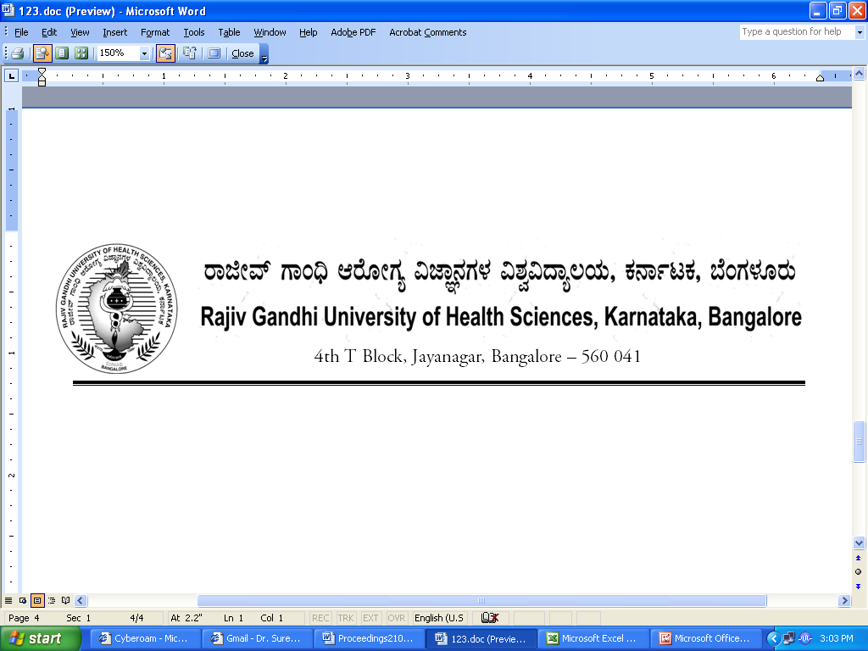

Dr.M.K.Ramesh Ph: 080-26961903, 26961946, Fax: 26961931
Registrar (Evaluation) Email: registrareva@rguhs.ac.in

Reg[E]/Exam/April- 2018 Dated: 26/12/2017

NOTIFICATION

Submission of Dissertation Books of ensuing M.Sc Nursing & MPT April /May -2018.

Sl No. | Name of the Events | Stream
1. | Dissertation – Submission to RGUHS | 16th January-2018  To  25th January -2018
2. | Dissertation Submission with  a. Fine of Rs 1.500/- per candidate till | 27th January- 2018  To  10th February-2018
2. | b. Fine of Rs 4.000/- per candidate from | 12th February- 2018  To  28th February- 2018

Note:
- The Principal of all colleges are inform to submit 4 CDs (Soft Copy) and only one Dissertation Book
- PG Guideship copy should be enclosed

By Order

Sd/-
Registrar (Evaluation)
To,

The Principal of all the concerned affiliated colleges.

